Come join in the fun of Troop 970’s WEBELOS

Haunted Halloween Campout

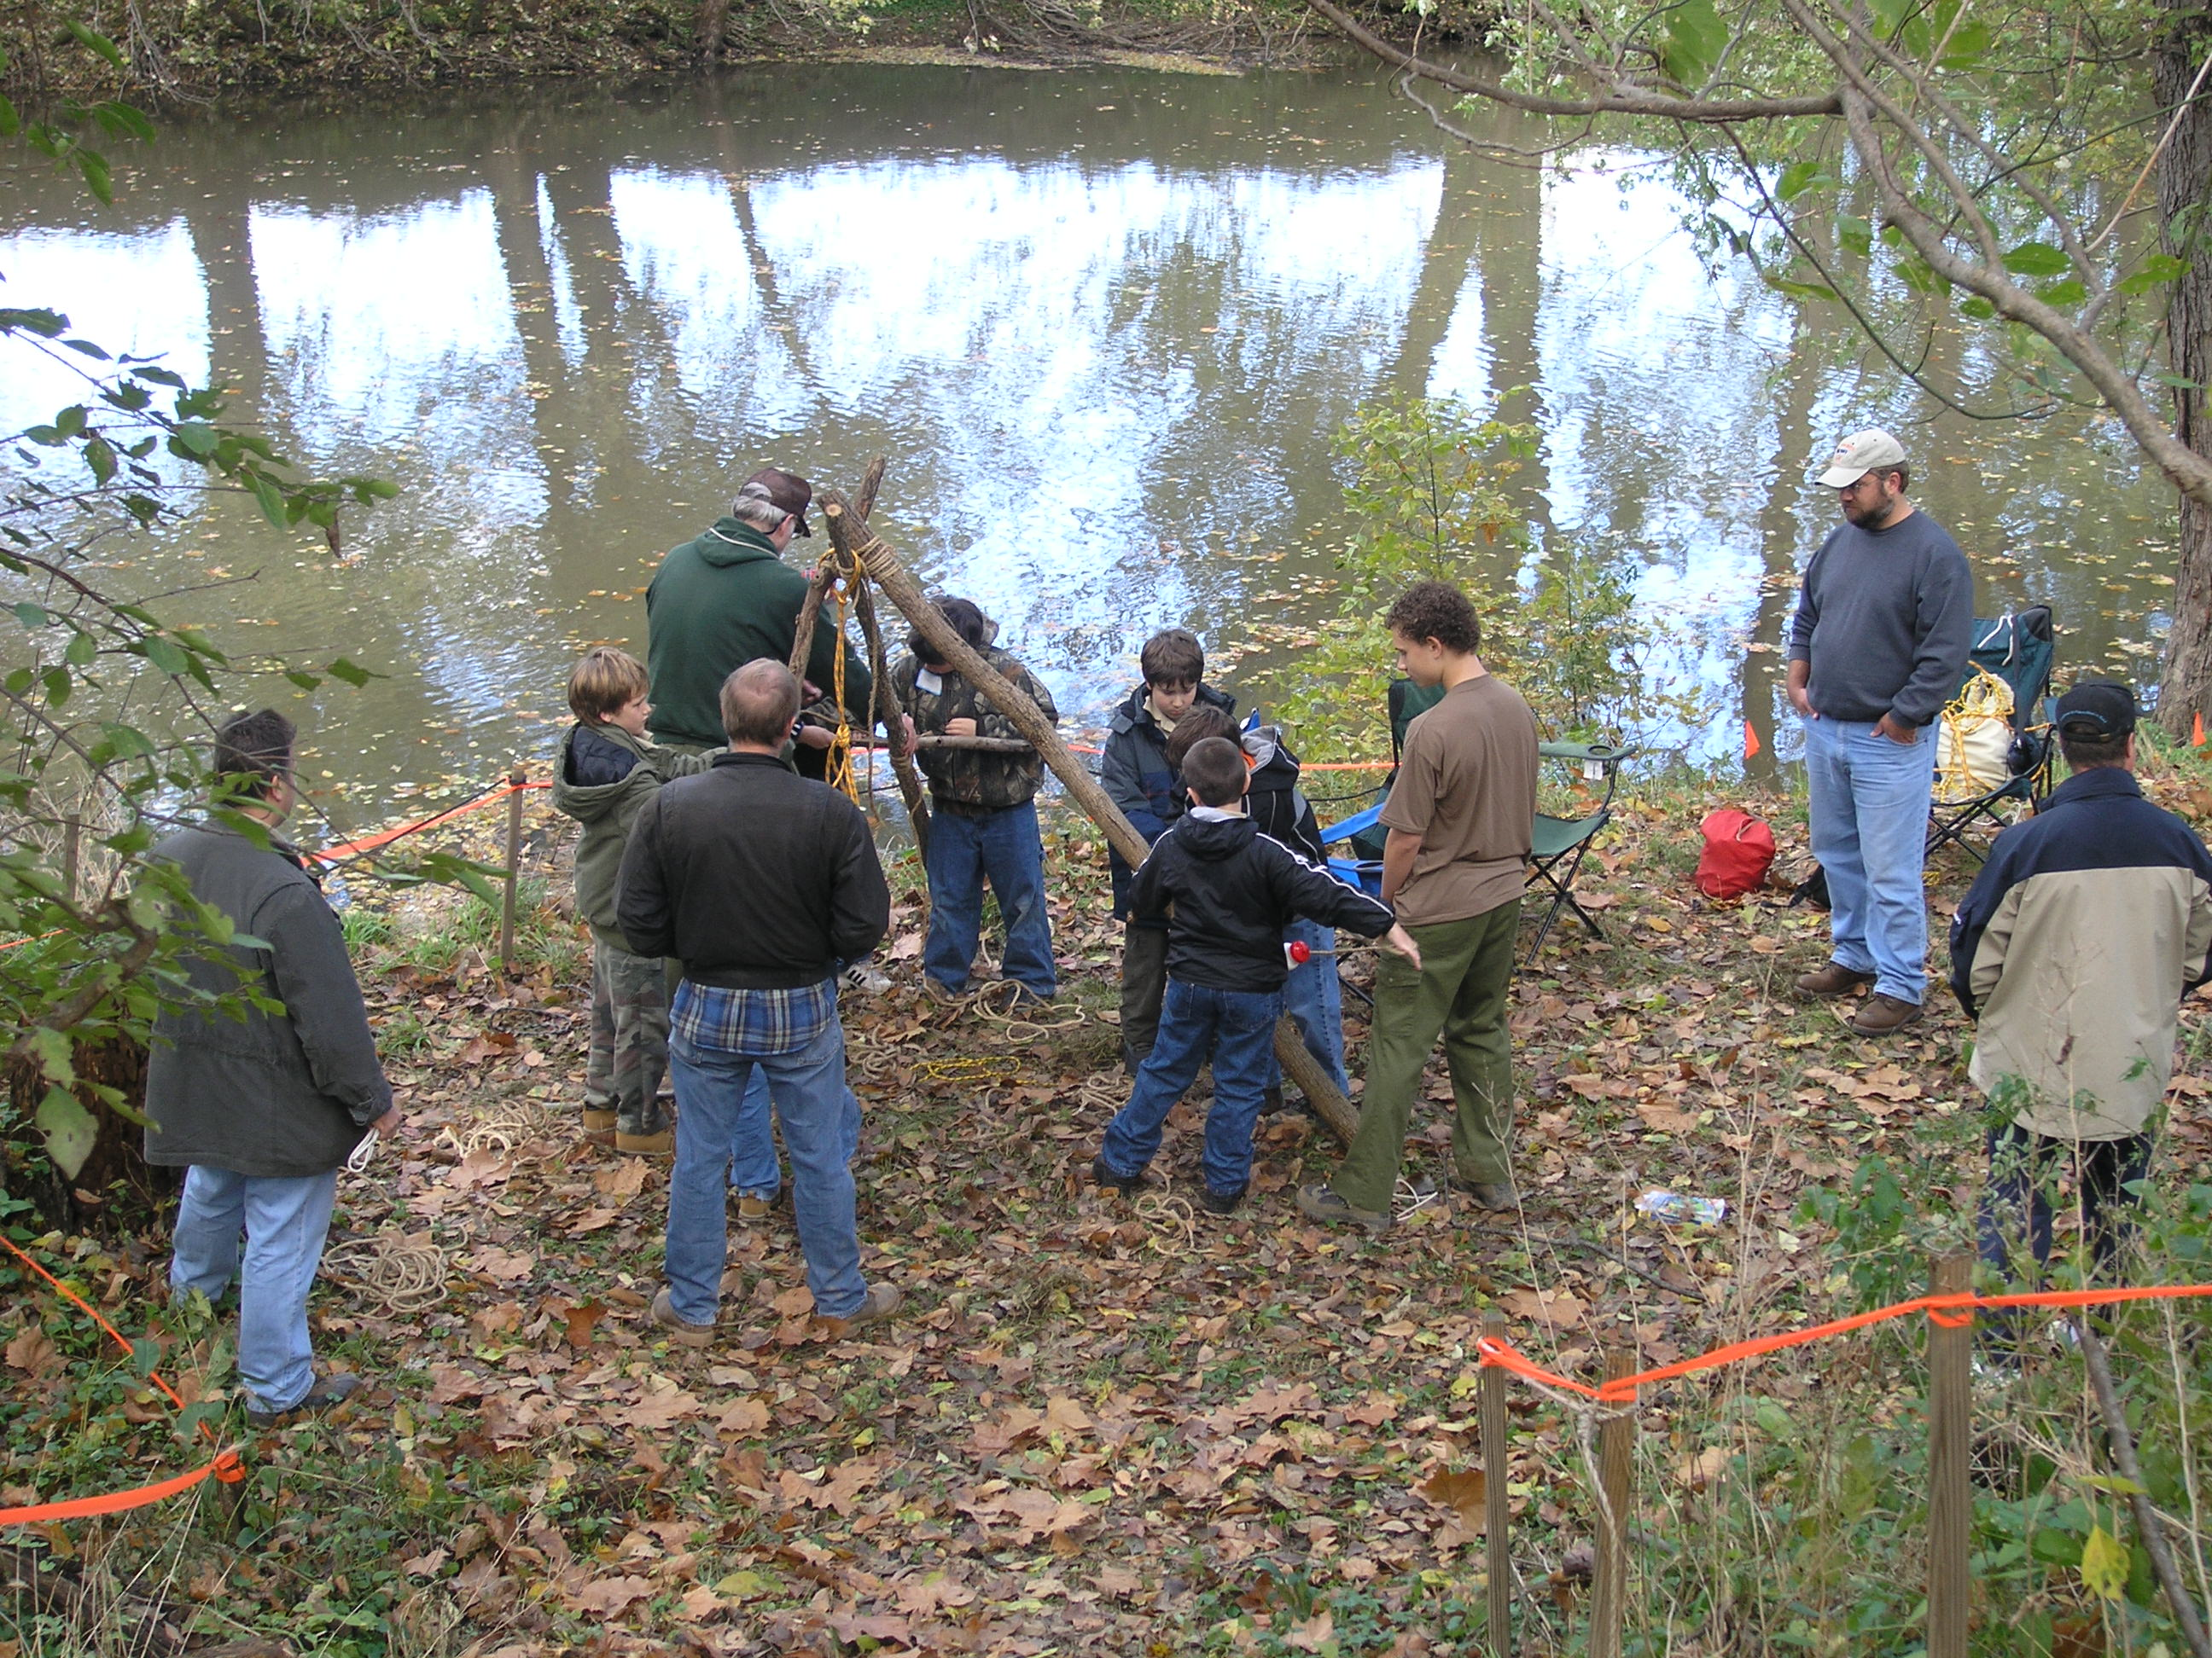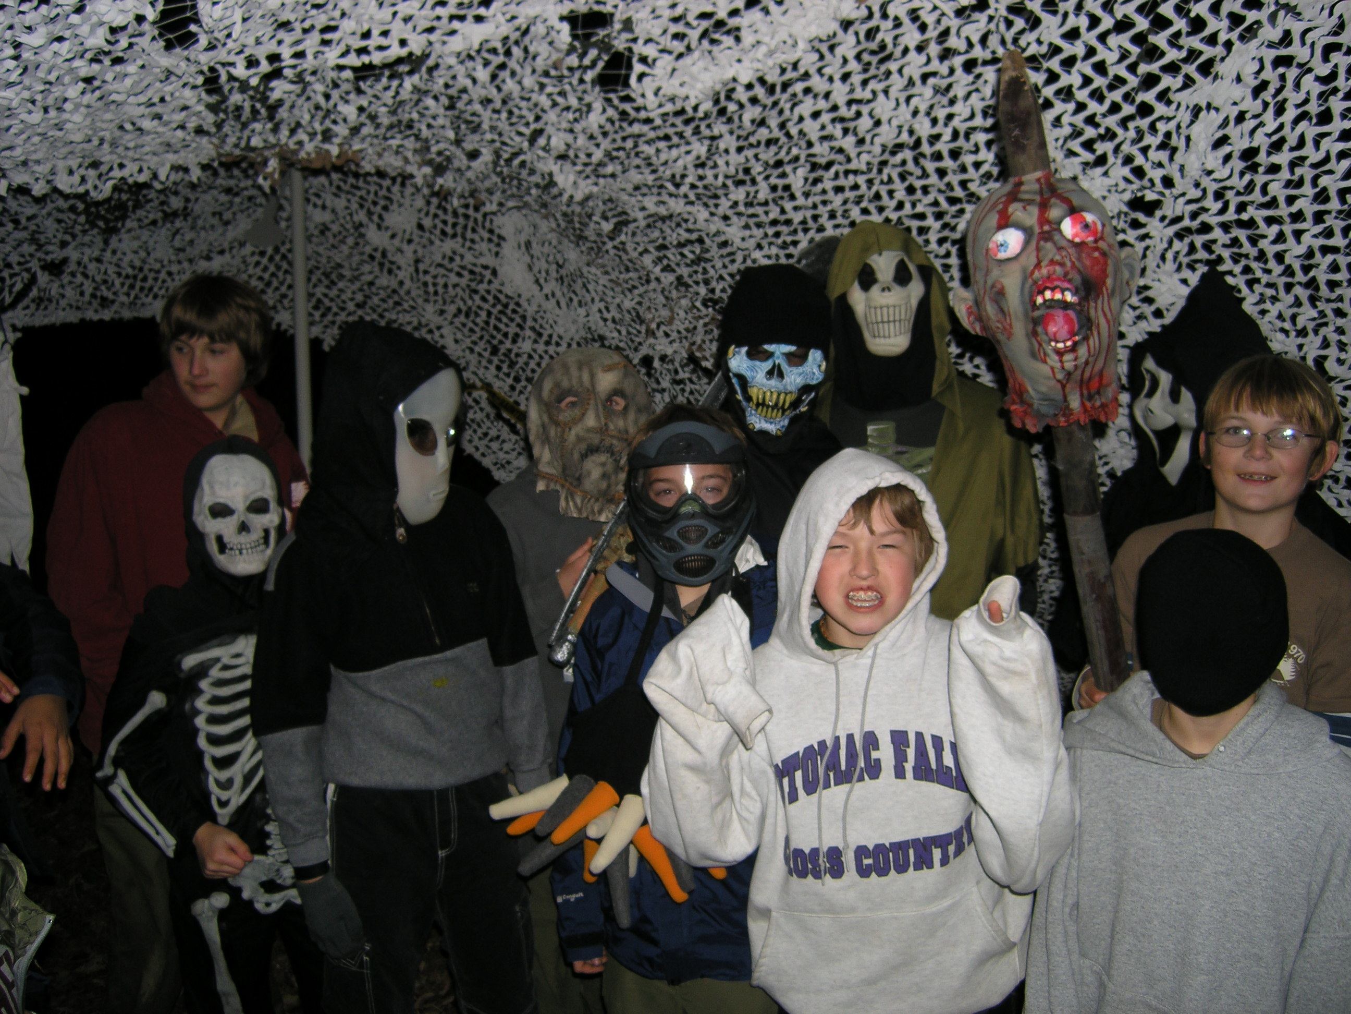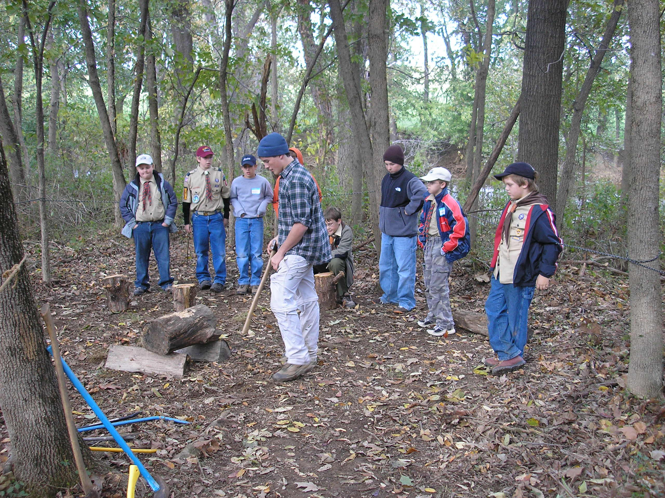

Where: “Camp 970” Corner of Island Drive and Potomac Drive, Ashburn (directions attached)
When: Saturday-Sunday 25-26 October, Webelos Scouts and Parents meet at Camp 970 at 1:00 PM Saturday, Event ends Sunday 26 October 9:00 AM

What: The weekend focuses on the fun Webelos Scouts and parents can have by joining Troop 970. Webelos can participate in Scoutcraft skills demonstrations and play games. Troop 970 will serve Saturday night camp dinner and conduct a Campfire, with a Halloween theme. Overnight Camping is available for Webelos and parents. Sunday - Rise and shine, camp breakfast provided, attend Worship Service, pack up and return home. Event fulfills Arrow of Light requirement #5 or #6

Fees: There is no fee for this event. Webelos Scouts and parents are guests of Troop 970.

Equipment: Troop will bring Troop tents, tarps, water and supplies, and patrol boxes. Scouts bring personal gear as found in Scout Handbook. Webelos and parents bring personal day event gear and personal sleeping bags and tents if camping overnight. If requested, tents can be provided.

Food: Saturday Lunch – Webelos should eat before event.
Saturday Dinner – Troop 970 cooks for Webelos and parents
Sunday Breakfast – Troop 970 cooks for Webelos and parents

SPECIAL NOTE FOR WEBELOS PARENTS:
This special event to introduce Troop 970 to your Scout and you will be run by BSA policy. You must attend the event with your Scout, and if he wants to camp overnight with us, must camp with your Scout. Only parent and son may occupy the same tent. We know everyone has a busy schedule, and so you may not be able to join us the entire day or overnight. Our event is designed so you can come, enjoy all or part of the event, camp with us or not as your schedule permits.
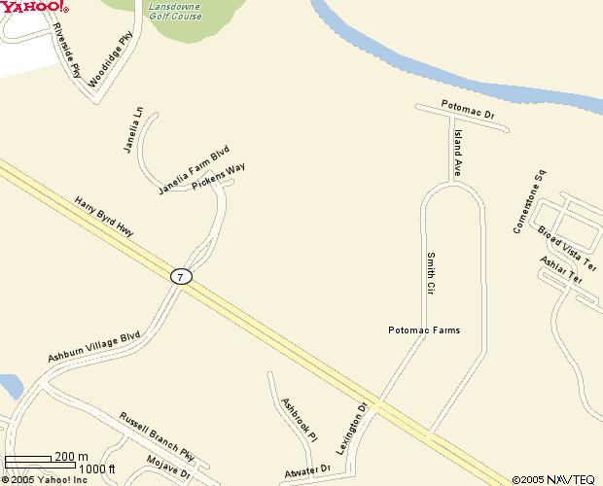
Directions:
West from Sterling/Countryside/Cascades
- Take Route 7 West to County Road 823 (Smith Circle), turn right on Smith Circle CAMP 970
- Take Smith Circle north, as it curves around west, turn right on Island Avenue
- Take Island Drive until it “T’s” on to Potomac Drive (gravel road), turn right on Potomac
- Look for Camp 970 signs on north side of Potomac

East from Ashburn
- Take Route 7 East to County Road 823 (Smith Circle), turn left on Smith Circle
- Take Smith Circle north, as it curves around east, turn right on Island Avenue
- Take Island Drive until it “T’s” on to Potomac Drive (gravel road), turn right on Potomac
- Look for Camp 970 signs on north side of Potomac
TROOP 970 WEBELOS HAUNTED HALLOWEEN REGISTRATION FORM

Return this portion to Mrs. Sandra Campbell (SandraCampbell06@aol.com) , or send to 21648 Mitchell Court Ashburn, VA 20147 no later than Thursday 22 October. Call 703-723-0284 for more info.

__________________and his parent __________________ of Pack _____will be attending Webelos Weekend.
Webelos Scout’s Name Webelos Parent’s name

We will be participating in the following events at Troop 970’s Webelos Weekend
________ Visiting the troop for all or part of the day, from _______ pm to _________ pm
________ Staying for Dinner. We have the following food allergies_____________________________
________ Staying for Campfire
________ Camping overnight with Troop 970. we have all our own camping gear (personal and tent)
________ Camping overnight with Troop 970. We have our own sleeping gear but need to share a tent

Emergency Contact ______________________________ Phone# __________________________

As the parent or legal guardian, I wish to inform the Troop 970 Scout Leaders and other medical professionals of
the following information concerning the above named Scout (please use additional paper as necessary):
Current or past medical conditions or restrictions, which may impact medical treatment, are: _________
__________________________________________________________________________________
__________________________________________________________________________________
Medications, which must be given regularly, their frequency and dosage are: _____________________
__________________________________________________________________________________
__________________________________________________________________________________
(Medications must be provided in the original prescription container, with medication name, dosage instructions and doctor's name legible.)

Scout's Medical Insurance Coverage Carrier: _____________________________________________
Policy # or ID Information _____________________________________________________________
Physician's Name _____________________________________ Phone:________________________
Address ___________________________________________________________________________
In the event that I cannot be reached in an emergency, I hereby give permission to the Troop 970 activity
leader to obtain medical attention from a physician and/or a hospital. I give my permission for the
physician and/or the hospital to treat this Scout in accordance with customary medical practices. I agree
to pay for any and all costs that may not be covered by my insurance policy.
My child is presently considered physically fit to participate in all Webelos Weekend activities (other than the
restrictions listed above.)

Parent or Guardian Signature: _______________________________________ Date: ____________
Parent or Guardian Printed Name: __________________________ Home phone: ________________
Home Address: ____________________________________E-mail_________________________________
Employer:_______________________________________________Work phone: ________________
Work Address: ______________________________________________________________________
Other Contact information (cell phone) ___________________________________________________
Note: Return this form to the Scoutmaster or a designated Troop 970 activity leader prior to attending any Scout
activity. This form, or a copy of it, will accompany the Scout while he participates in the activity. Scouts, who do not
have a copy of this form on record with the Scoutmaster, must be accompanied by a parents or a legal guardian.

